# Probability and ststistics:

## Day 1:

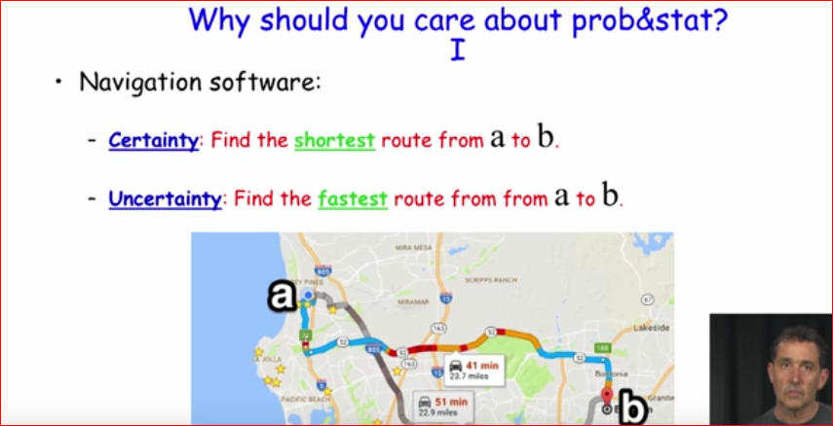

* There can be certain data and also there can be uncertainity in data also,

When we have to find fastest route that situation can be uncertain therefore we have to look after **statistic.**

Another example:

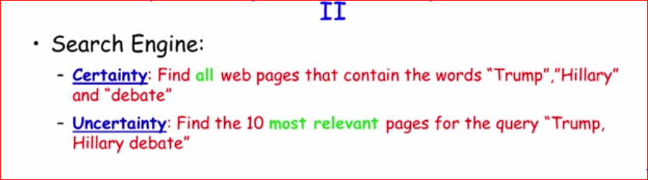

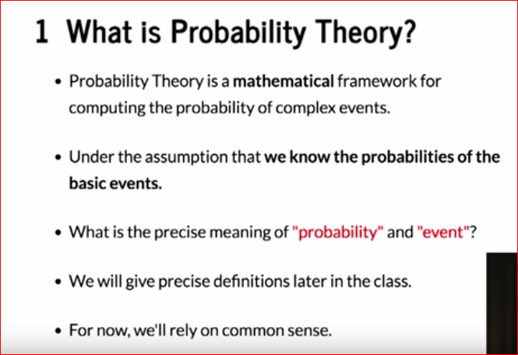

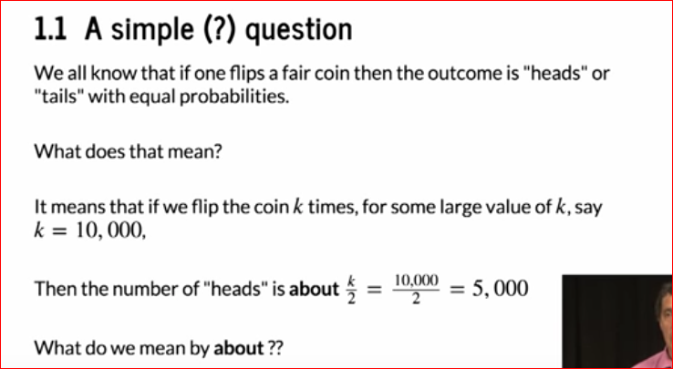

How far we are from that about ie how far we are from 5000 in above example?

That about can be calculated mathematically as:

This is called as simulation.

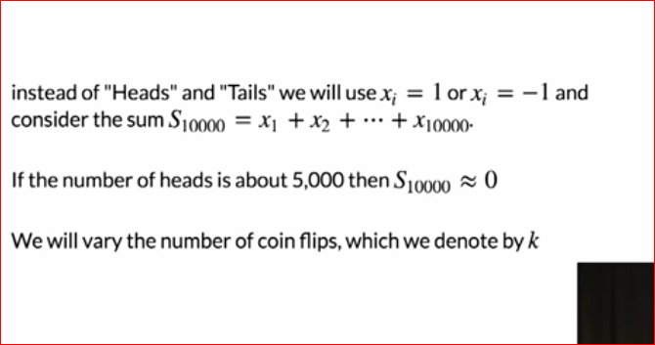

Code for generating sum of k times coin flipping of n number of coins ie sum matrix: 1*n dimension matrix

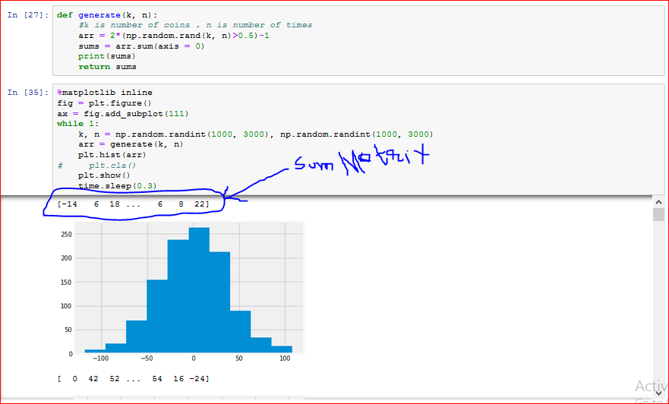

It means that any value in sk cannot exceeds 4rootk : prob is very less

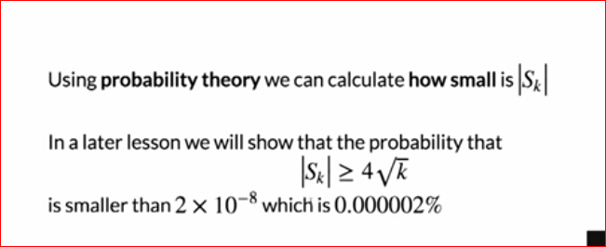

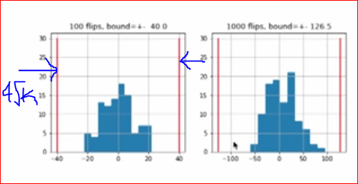

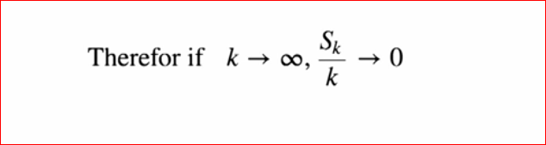

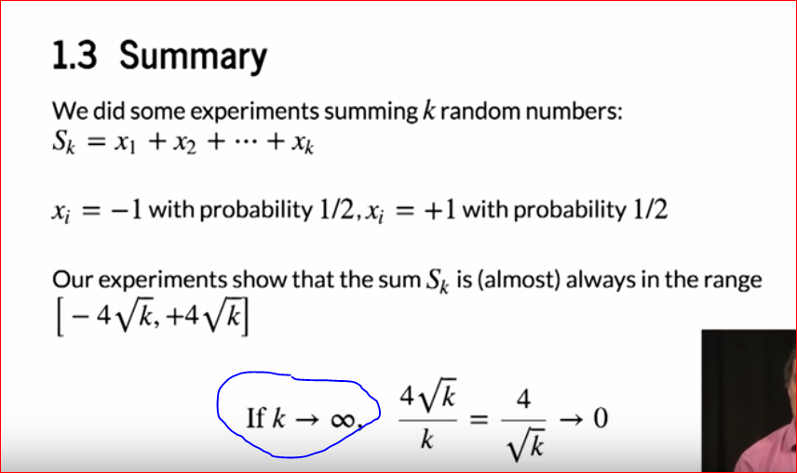

Why I am calculating sum ?

The prob of heads and tails is 0.5 right!!

1 represents heads and tails represents -1 right!!!

Head and tail should come equal number of time !!!

Therefore sum of head and tail outcoming should be close to 0

-1+1+1+1+1+……………….+-1 = 0 acc. to probability theory

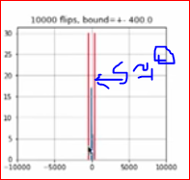

We **have proved practically if k== infinity then sum == 0**

Hence proved practically!!!!!

Why is statistic?

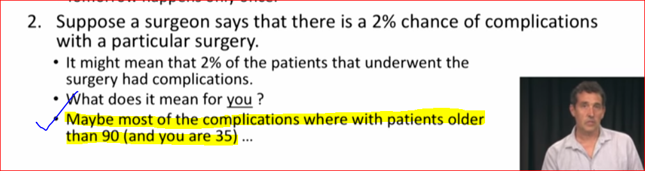

That’s the reason why we are using stats !!!

Probability has given u the 2 per chance of complication!!!

What if that 2 per persons which have complications are 90 yrs old

Then what that mean to u?

Acc to stats there is 0 per prob if u are less than 90 yrs old for any complication!!!

Set Theory:

Venn diagram using python as tool:

